Sample Abstract of Neutron4: Information for Authors

First Author^{1*}, Second Author², Third Author¹ (11-point)
¹First Affiliation
²Second Affiliation (if different)
*abc@defg.hij.ac.it (Corresponding author, 10-point)

Abstracts are limited in length to one page.
For A4 paper, the abstract should have 25mm top margin and 20mm side and bottom margins. The complete printed area including title, authors, text, figures and references must fit within these margins. Please use this file as a template.
The Title (in 14-point Times New Roman, bold) should be centered at the top of the page. The title should be followed by the authors’ names, and in the case of multiple authors, the presenter’s name should be underlined. The names should be followed by the author affiliations, including complete addresses, in italic type, with one affiliation per line. The presenter’s e-mail address of the author (indicated by an asterisk (*) next to the name) should be given after the list of affiliations.
Authors and main text should be in 11-point Times New Roman; affiliations and the contact e-mail should be in 10-point Times New Roman. The authors, affiliations, and contact e-mail should be centered, and the main text should be justified. Use single spacing throughout the document but insert a blank line between the title and authors, as well as between the contact e-mail and the text.
References within the text should appear in square brackets [1]. Figures and tables must be inserted at the proper position and size within the text and with proper captions.
The filename must include the presenter’s name and contribution type (Oral_DoeJohn.doc or Poster_RossiMario.docx.). The maximum allowed file size is 5 MB.
Please upload the abstract and fill the registration form at www.sisn.it/neutrons4/ by May 31st, 2025.

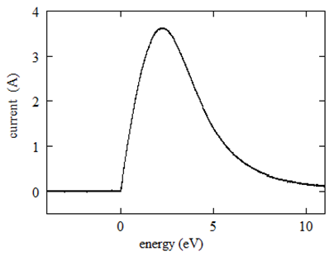
Fig. 1 Caption. (9-point)

Test | Table | Value
1 | 6 | 11
2 | 7 | 12
3 | 8 | 13
4 | 9 | 14
5 | 10 | 15
Tab. 1 Caption. (9-point)

References (optional, 10-point)
- A.B. Sample et al, Phys. Rev. Lett. xx (19xx) xxxx.
- C.D. Sample et al, Phys. Rev. Lett. yy (20xx) yyyy.

